Remote Work Job Market Analysis
1.Project Overview
This project aims to analyze the evolving dynamics of the job market in different industries by examining employee demographics, work patterns, well-being indicators, and organizational support factors. The goal is to uncover trends and correlations insights that can help organizations to optimize work policies, improve employee satisfaction, and enhance productivity.
2. Dataset Description:
-Rows: 5001
-Columns: 20
-Key attributes:
-Demographics: ID, Name, Gender, Work Location, Region, Industry, Job Role, Years of Experience
-Work Patterns: Hours of Work per Week, Number of Virtual Meetings
Well-being Indicators: Work-Life Balance Rating, Stress Level, Mental Health Condition, Sleep Quality
-Performance & Engagement: Productivity Change, Satisfaction with Remote Work, Company Support for Remote Work

3. Scope of Analysis:
- Workforce Demographics & Distribution – Understanding the composition of the workforce across industries, regions and experience levels.
- Workload & Meeting Culture – Analyzing the relationship between working hours, meeting frequency, and employee well-being.
- Well-being & Mental Health – Identifying patterns in stress, mental health conditions and sleep quality in different work location (onsite, hybrid, remote) settings.
- Productivity & Satisfaction – Exploring how different work location impacts productivity and job satisfaction and company support.
- Regional & Industry Trends – Comparing remote work experiences across different regions and industries.
- Exploratory Data Analysis and Data Analysis using SQL
We began with data preparation, cleaning and structured analysis in SQL SERVER to answer key business questions:
● Data Loading: First we create a Database in SQL Server and then load data which is in csv file format with the help of task option.
● Initial Exploration: find out the total number of records we have for analysis

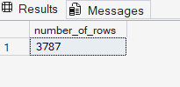

● Cleaning the data: Delete the data which we do not find necessary for our EDA process. We drop column Access_to_mental_Health, Social_Isolation, physical_activity.

● Data Exploration
1. Productivity and Workload
- Calculate average hour per week: We will find the average hour of an employee in a week.

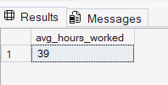

  - Calculate meeting per employee per week: We will find the average meeting of an employee in a week.

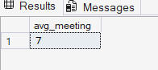

2.Employee well being
- Calculate average work life balance rating: We will find the average
work life balance rating.

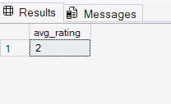

- Organisational Support
  - Calculate average company support rating: We will find the average company support rating.

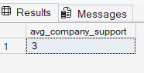
  - Calculating % employee reporting high support: Calculate the percentage of employee reporting high support (>=4).

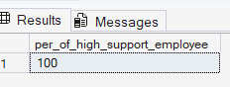
- Employee by Mental Health Condition: Categorize the number of employee according to their mental health condition.

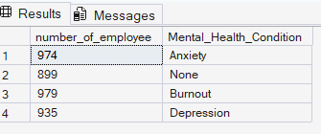

- Employee by Gender and Stress Level: Categorize the employee according to their stress level and gender
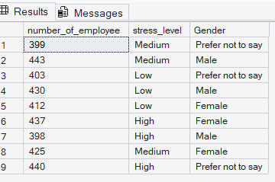

6.Employee by Work Location and Gender: Find the total number of employee on work location and categorize by gender.
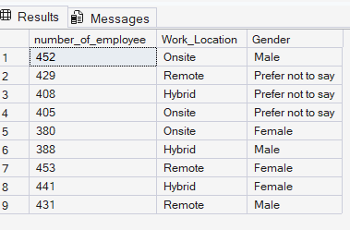

7.Employee by Productivity Change and Gender: Categorize the employee by productivity change and gender.

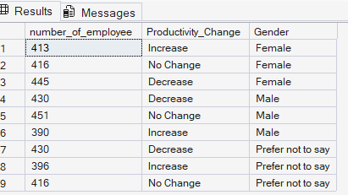

7.Employee by Sleep Quality and Gender: Categorize the employee by sleep quality and gender.
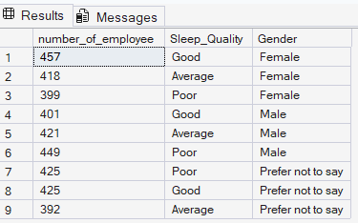

8.Employee by Satisfaction with remote work and Gender: Categorize the employee by satisfaction with remote work and gender.
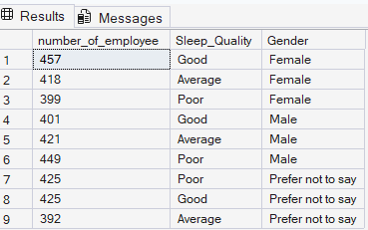

9.Employee by Job role and Gender: Categorize the employee by job role and gender.

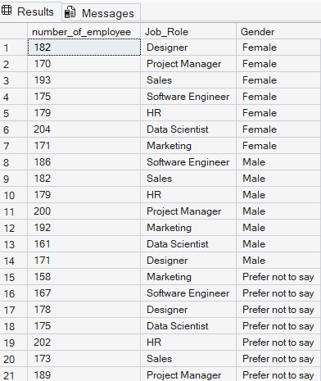

10.Employee by Industry and Gender: Categorize the employee by industry and gender
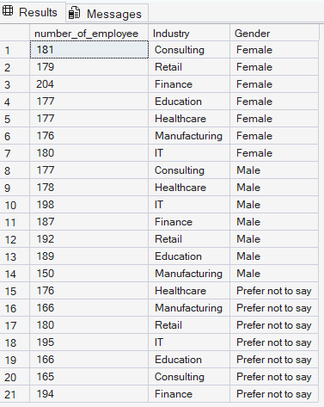
11. Average Age by Job role and Gender: Calculate the average age of employee in each job role and categorize by gender.
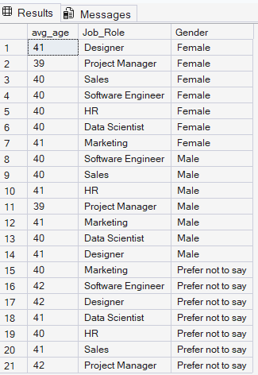

12.Average Age by Industry and Gender: Calculate the average age of employee in each industry type and categorize by gender.
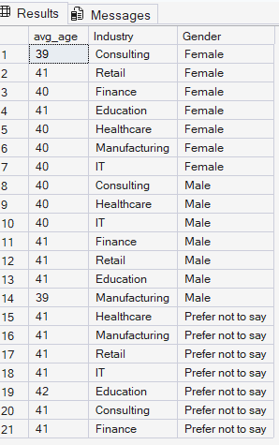
13. Employee by Year of experience: Calculate the total number of employee with their respective year of experience.
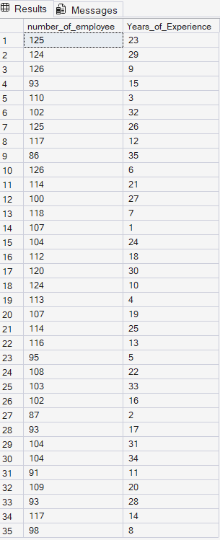

5 Dashboard in Power BI
Finally, we built an interactive dashboard in Power BI to present insights visually.
